A Project Report
On

Infrastructure Management System

This is to certify that the project work entitled “Infrastructure Management System for Vishakhapatnam Steel Plant” is submitted by xxxx student of B.Tech third year in order to fulfill the required curriculum of the mini project to be submitted in the college. It is a bonafied record of work carried out by her in the IT Department of VSP.
.

DECLARATION

We here by declare that the project title “PORT SCANNER”, Submitted by us to xxxxx affiliated to JNTU, is original in nature and is bonafide one carried out by us .
The project is being submitted in partial fulfillment of the requirement for the award of bachelor of technology. The reports have not been submitted either in part or in full for degree or diploma earlier to this University or any other University.

Acknowledgement

INDEX

- ABSTRACT

- INTRODUCTION
  - OBJECTIVE
  - SCOPE
  - EXISTING SYSTEM
  - INTERFACE REQUIREMENTS

3. PROJECT ANALYSIS
  - STUDY OF THE SYSTEM
  - PROJECT FEATURES

4. PROJECT DESIGN
  - UML DIAGRAMS
  - DATA BASE TABLES
  - SCREENS SHOTS

5. CONCLUSION

6. BIBLOGRAPHY

ABSTRACT

Visakhapatnam steel plant is having more than 50 numbers of servers to handle various operations in Steel Plant. Periodical Maintenance of these servers is a crucial activity. Server Management System is intranet based web application, which is designed by Information Technology Department of Visakhapatnam Steel plant to log details of servers online by System Server Group. The web based application is used within their organization under the distributed accessibility. This application is actually developed to cater to reduce physical work of maintaining log books in their work. Servers are the main hardware in computerization of various activities in Steel Plant. This System applies to every server used in data and application storage and processing.

IMS consists of following modules/activities:

    - Server Management

    - Server Maintenance

    - Cartridge Management

    - Mock Restoration

    - Software Management

    - Document Management

Server Management

Description
Visakhapatnam Steel Plant maintains several servers to host various applications that are used in the Plant. These servers’ details are maintained for future maintenance. These details include server name, server make, date of purchase etc…

Server Maintenance

Description
Periodically, server maintenance is done and the details are captured. These details include server name, date of maintenance, problem found, and parts replaced etc….

Cartridge Management

Description
Periodical backup is taken for various applications on request along with regular backup. Tape Cartridges are used for the backup. Cartridge details include cartridge name, backup number, state etc…

Mock Restoration

Description
Backed up data is restored whenever it is required. Mock Restorations are done to check the correctness of the data written on Cartridge. These details include cartridge name, restoration date etc….

Software Management

Description
Software received along with various hardware devices are managed properly. Software type, hardware details and rack no are captured.

Document Management

Description

Various documents received along with servers are managed properly. Details of the documents and their storage details are captured.

INTRODUCTION

OBJECTIVE

Visakhapatnam steel plant is having more than 50 numbers of servers to handle various operations in Steel Plant. Periodical Maintenance of these servers is a crucial activity. Server Management System is intranet based web application, which is designed by Information Technology Department of Visakhapatnam Steel plant to log details of servers online by System Server Group. The web based application is used within their organization under the distributed accessibility. This application is actually developed to cater to reduce physical work of maintaining log books in their work.

SCOPE

Servers are the main hardware in computerization of various activities in Steel Plant. This System applies to every server used in data and application storage and processing.

EXISTING SYSTEM

Presently server management information is maintained through log book.

INTERFACE REQUIREMENTS

User Interfaces

NA

Hardware Interfaces
- Pentium IV Processor.
- 128 MB RAM.
- 20GB Hard Disk space.
- Ethernet card with an Internet and Internet zone.

Software Interfaces

- Windows 98 or 2000 or XP operating system.
- Internet explorer 5.0 and Netscape navigator.
- Visual Studio 2005
- Front end: asp.net with C#
- Oracle 9i as back end
- IIS.

Communications Interfaces

- The user should be able to see the report without vertical and horizontal scroll

- If scroll is required then it is should be minimum.

- The user should be able to take neat print out of the report

- The login and display of the information would short time. For log in maximum time should be 5 seconds and fro display of information the maximum time should be 10 seconds.

Project Analysis

STUDY OF THE SYSTEM:

Generally maintaining infrastructure details like server details, cartridge details, mock details, software and document details of a particular server through log book became crucial activity. So mainly this application is developed to reduce the physical work of maintaining through log books.

This application is generally for infrastructure management group of steel plant who takes care of the entire infrastructure in the department. With this application accessibility of particular information is easier than in log books. Redundancy of the data will not be there while maintaining infrastructure details through this application and the searching process will be reduced. Data has more security while using this application. Only authenticated users can log on to this and they only can create or modify the details. And the details of user (employee no, time of entered) are recorded in database when he creates or modifies the data.

Need for Computerization
    - Duplication of work avoided
    - Paper work is drastically reduced
    - Retrieval and access of data is easy
High-Level Project Goals

· Improve efficiency in the department

· Availability of online service

· Availability of data to senior officials for quick decision making

· Better administration

Project Features:
Infrastructure Management System (IMS) basically is a web based application using .Net environment for server management.

The Key features of IMS are:

- User friendly application for server management and maintenance process.

- Online availability of server status.

Modules:

    - Server Management

    - Server Maintenance

    - Cartridge Management

    - Mock Restoration

    - Software Management

    - Document Management

Server Management

Description
Visakhapatnam Steel Plant maintains several servers to host various applications that are used in the Plant. These servers’ details are maintained for future maintenance. These details include server name, server make, date of purchase etc…

Server Maintenance

Description
Periodically, server maintenance is done and the details are captured. These details include server name, date of maintenance, problem found, and parts replaced etc….

Cartridge Management

Description
Periodical backup is taken for various applications on request along with regular backup. Tape Cartridges are used for the backup. Cartridge details include cartridge name, backup number, state etc…

Mock Restoration

Description
Backed up data is restored whenever it is required. Mock Restorations are done to check the correctness of the data written on Cartridge. These details include cartridge name, restoration date etc….
Software Management

Description
Software received along with various hardware devices are managed properly. Software type, hardware details and rack no are captured.

Document Management

Description

Various documents received along with servers are managed properly. Details of the documents and their storage details are captured.

PROJECT DESIGN

UML DIAGRAMS

Use Case Diagram for Login:

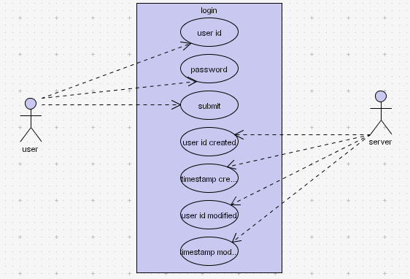

Diagram for Home Screen:

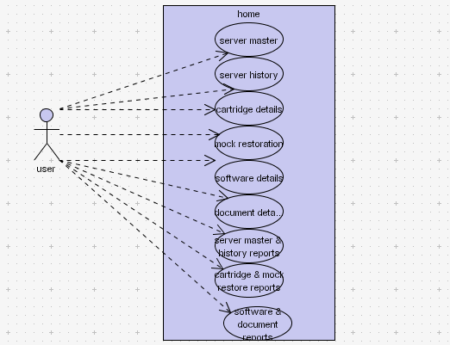

Diagram for Main Screens:

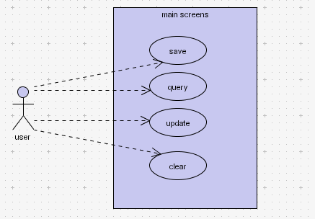

Diagram for report screens:

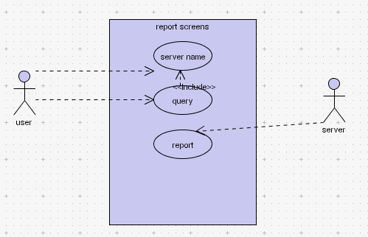

DATABASE TABLES

Login

Description

Authenticity of the user is checked by this screen. If the user is having valid user id and password then the user id allowed navigating through the home page.

Table name:
Id

Field Description | Data Type(Size) | Remarks
user_id | Varchar2(6) | It is user’s login id
Password | Varchar2(10) | It is login user’s password

Server Management

This table gives the details of server and its various fields. ….

Table name:
tssg_server_master

Field name | Data Type(Size) | Description
server_name | Varchar2(30) | It is server name and it is primary key
server_ip | Varchar2(20) | It is server ip address
server_alias | Varchar2(30) | It is another name of server
server_make | Varchar2(30)
server_model | Varchar2(30)
server_type | Varchar2(30)
server_slno | Varchar2(30) | It is server serial number
server_cpu_det | Varchar2(30) | It is about cpu details of server
server_ram | Varchar2(30)
server_disks | Varchar2(30)
server_pci_x | Varchar2(30)
server_os | Varchar2(30) | It is server operating system
server_db_as | Varchar2(30) | It is database application server
server_serv_hosted | Varchar2(30) | It is service hosted
server_appl_hosted | Varchar2(30) | It is server application hosted
server_mgmt_act | Varchar2(30) | It is server management activities
server_monitor_act | Varchar2(30) | It is server monitor activities
server_bck_plan1_dt | Date | It is server back up plan1 date
server_bck_plan2_dt | Date | It is server back up plan2 date
server_proc_at_no | Varchar2(30) | It is server process acceptance trader number
server_proc_at_dt | Date | It is server process acceptance trader date
server_inst_dt | Date | It is server installation date
server_warrty_exp_dt | Date | It is server warranty expiry date
server_supplier | Varchar2(30)
server_maint_agency | Varchar2(30) | Server maintenance agency
server_location | Varchar2(30)
server_rack_name | Varchar2(30)
server_rack_position | Number
user_id_created | Varchar2(6)
timestamp_created | timestamp
user_id_modified | Varchar2(6)
timestamp_modified | timestamp

Server Maintenance

Periodically, server maintenance is done and the details are captured.

Table name:
- tssg_server_history
Field Description | Data Type(Size) | Description
server_name | Varchar2(30)
problem_report_date | Date
problem_description | Varchar(200)
oem_agency | Varchar(100) | It is original equipment manufacture agency
call_report_dt | Date | It is call report date
server_availabilty_status | Varchar(10)
server_down_date | Date
server_restart_date | Date
call_attend_dt | Date
call_attend_engg | Varchar(30)
problem_part_no | Varchar(30)
problem_part_desc | Varchar(100)
problem_reasons | Varchar(100)
actions_taken | Varchar(100)
remarks | Varchar(100)
user_id_created | Varchar(6)
timestamp_created | Timestamp
user_id_modified | Varchar(6)
timestamp_modified | Timestamp

Cartridge Management
This table maintains the details of cartridges and its various fields

Table name:
tssg_server_cartridges
Field Description | Data Type(Size) | Description
cart_label | Varchar2(20)
cart_make | Varchar2(20)
cart_type | Varchar2(20)
cart_capacity | Varchar2(20)
cart_purpose | Varchar2(30)
cart_location | Varchar2(30)
cart_status | Varchar2(10)
cart_init_label_date | Date | It is cartridge initialization label date
cart_closed_date | Date
cart_contents | Varchar2(100)
remarks | Varchar2(100)
user_id_created | Varchar2(6)
timestamp_created | Timestamp
user_id_modified | Varchar2(6)
timestamp_modified | Timestamp

Mock Restoration
Table name:
tssg_cartridges_mock_restore

Field Description | Data Type(Size) | Description
cart_label | Varchar2(20)
cart_mock_restore_dt | Date | it is cartridge mock restoration date
cart_closed_date | Date
remarks | Varchar2(100)
user_id_created | Varchar2(6)
timestamp_created | Timestamp
user_id_modified | Varchar2(6)
timestamp_modified | Timestamp

Software management:

Table name:
tssg_software_details

Field Description | Data Type(Size) | Description
media_label | Varchar2(20)
part_no | Varchar2(20)
type_media | Varchar2(10)
software_category | Varchar2(20)
media_description | Varchar2(200)
media_date | Date
media_location | Varchar2(100)
Remarks | Varchar2(100)
user_id_created | Varchar2(6)
timestamp_created | Timestamp
user_id_modified | Varchar2(6)
timestamp_modified | Timestamp

Document Management
Table name:
tssg_document_details

Field Description | Data Type(Size) | Description
document_label | Varchar2(20)
document_category | Varchar2(20)
document_description | Varchar2(100)
document_location | Varchar2(30)
document_date | Date
Remarks | Varchar2(100)
user_id_created | Varchar2(6)
timestamp_created | Timestamp
user_id_modified | Varchar2(6)
timestamp_modified | Timestamp

SCREEN SHOTS

Functional Requirements

The functional requirements have been divided to various logical modules, further drilled down to the level of individual functionalities. Each function requirement is illustrated in different section heads:

- Description of the function
- Input
- Screen
- Processing
- Output

Operational Concepts and Scenarios
After successful login the system, the home page will be displayed to the user. When the user clicks on a particular menu option, the corresponding screen/form will be displayed on screen.

Login
Authenticity of the user is checked by this screen. If the user is having valid user id and password then the user id allowed navigating through the home page.

Input
Data Stores:
Id
Processing

The user authentication is checked by this screen. When the screen is displayed, user has to enter the user id and password. If user enters valid user id and password, then the user will be directed to HOME page.

Otherwise if user enters invalid user id, then a message will be displayed that “invalid user id” and if user enters invalid password, then a message will be displayed that “invalid password. Please enter correct password to login to the home page”

Query

N/A

Save

N/A

Clear

N/A

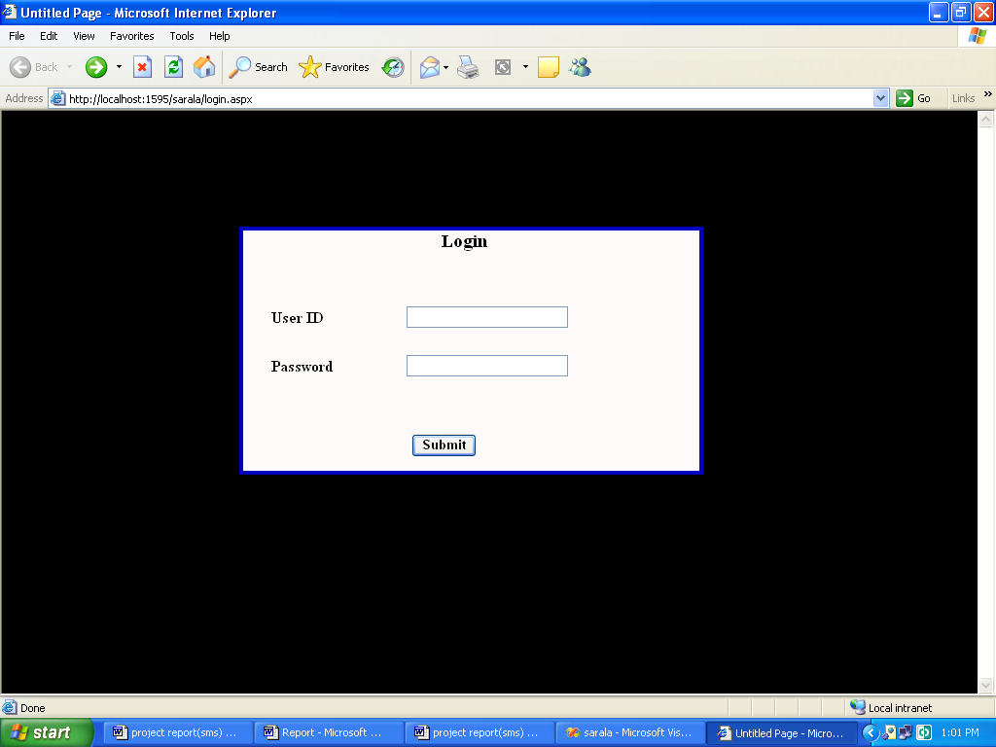

Home
Description
This is the screen where all the links are displayed for required screen. When user clicks the link, corresponding screen will be displayed.
Data Store
Nil

Processing
Nil
Query:
Nil
Save
Nil
Update
Nil
Clear
Nil

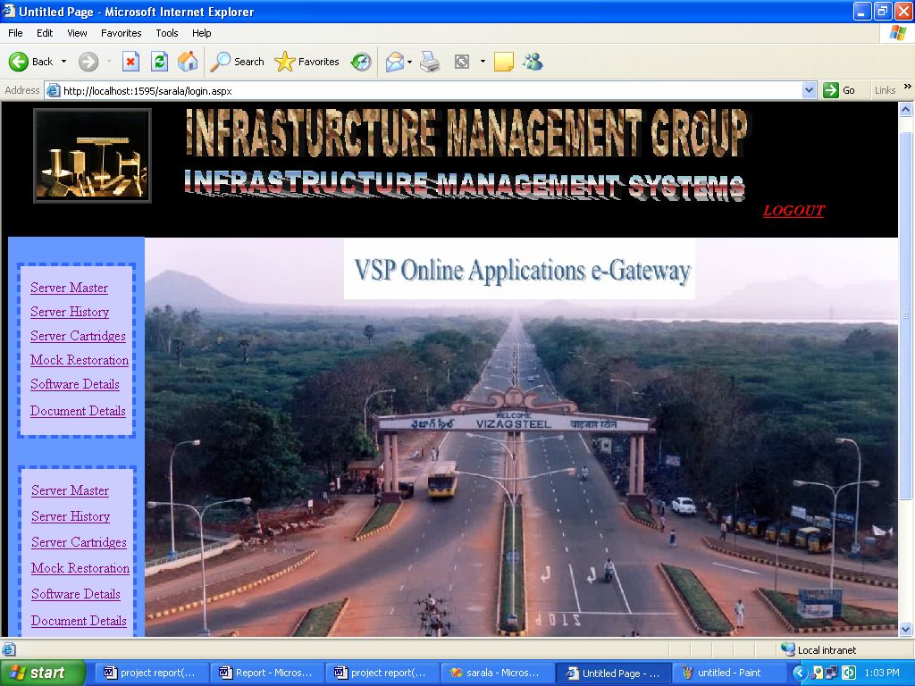

Server Management

Description

Visakhapatnam Steel Plant maintains several servers to host various applications that are used in the Plant. These servers details are maintained for future maintenance. This screen is designed to enter the server details such as server name, server ip, server ram, server disks etc.
Input

Data Store:
- tssg_server_master

Processing
After clicking Server Master link in the home page Server Master Screen will be displayed. There user can enter the details of server such as server Name, Server Back up Plan dates, Server Supplier etc.
Save
After entering the details of server in the corresponding text boxes, Save button is pressed to insert the record. If user has not entered the server name or if the server name is not unique then a warning will be displayed as Server Name is Primary Key.
Query
All the details of Server Master record will be populated in the corresponding text boxes after clicking Query button by entering server name in the corresponding text box. Server Name field is deactivated after query button is clicked. Because user should not modify the server Name.
Update
Data is updated through the server name. User enters the server name and clicks Query button then corresponding record from the database are displayed in the text fields and if user wants to update the data user can click Update button to update the record in the data base.
Clear
Clear button is clicked to erase the values in the text fields.

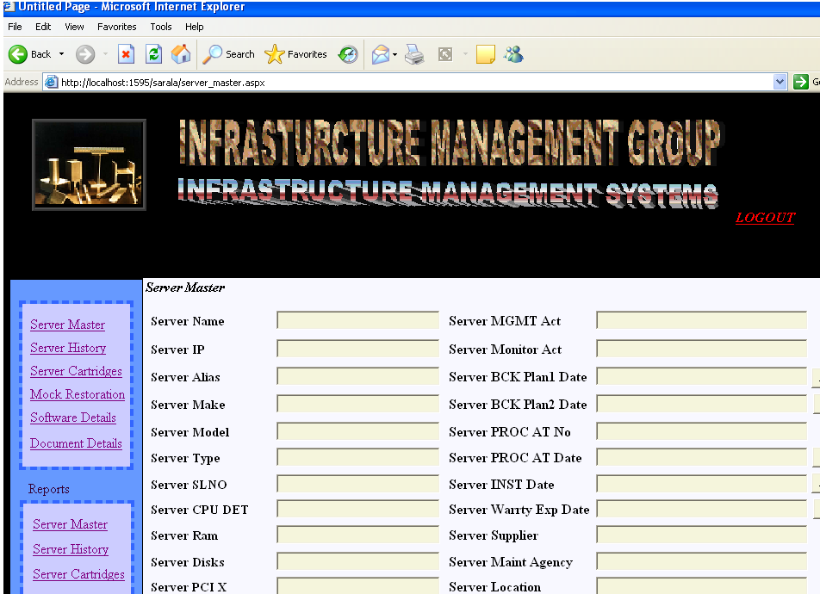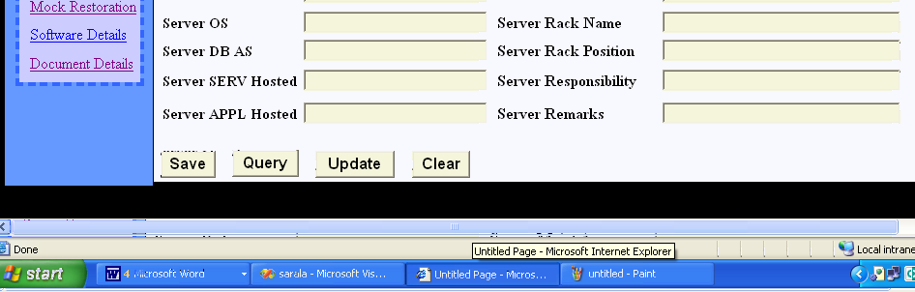

Server Master Report

To display all the details of server master table user has to click the Server master reports link button, then server master reports screen will be displayed. There by clicking Query button all the record of server master table will be displayed. If user wants to see particular record of server master then he has to enter the server name field before clicking Query button.

Report screen after clicking Query button is as shown below

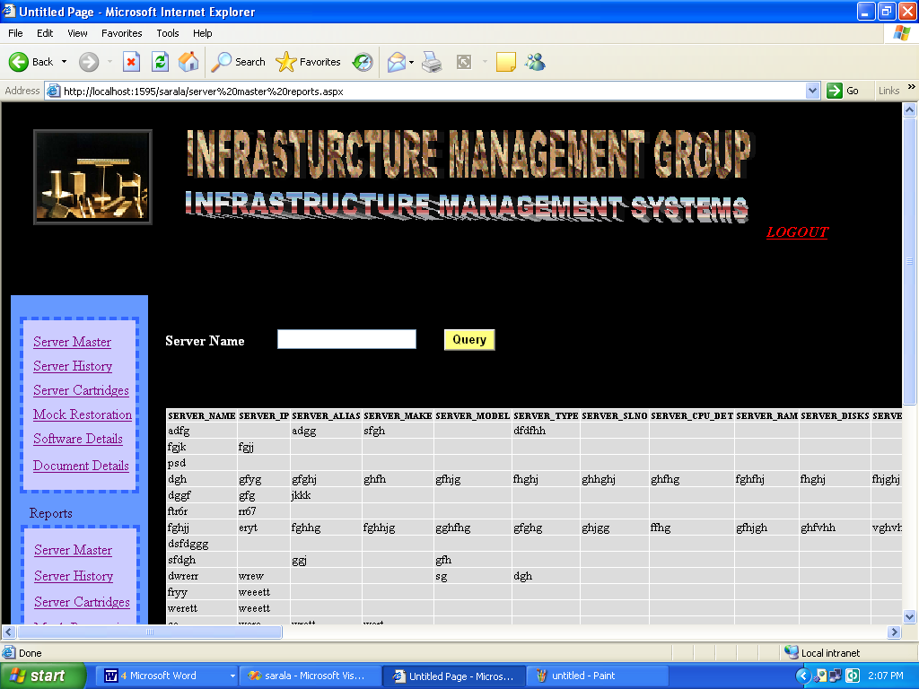

Server Maintenance

Description
Periodically, server maintenance is done and the details are captured. These details include server name, date of maintenance, problem found, and parts replaced etc….
Input

Data Store:
- tssg_server_history
Processing
After clicking Server History link in the home page Server History Screen will be displayed. There user can enter the details of server such as server Name, problem report date, problem description, remarks etc.

Save
After entering the details of server in the corresponding text boxes, Save button is clicked to insert the record. If user has not entered the server name or if the server name is not unique then a warning will be displayed as Server Name is Primary Key.

Query
All the details of Server History record will be populated in the corresponding text boxes after clicking Query button by entering server name in the corresponding text box. Server Name field is deactivated after query button is clicked. Because user should not modify the server Name.
Update
Data is updated through the server name. User enters the server name and clicks Query button then corresponding record from the database are displayed in the text fields and if user wants to update the data user can click Update button to update the record in the data base.
Clear
Clear button is clicked to erase the values in the text fields.

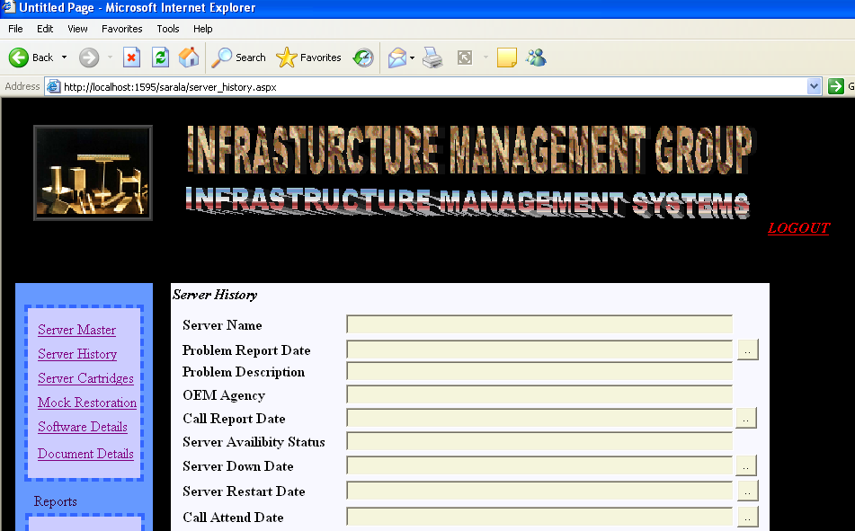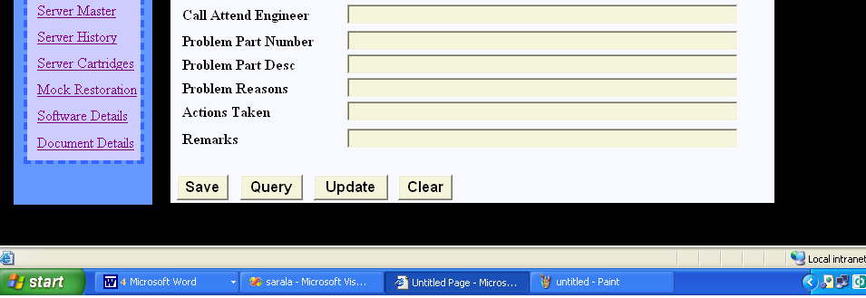

Report
To display all the details of server history table user has to click the Server history reports link button, then server history reports screen will be displayed. There by clicking Query button all the record of server history table will be displayed. If user wants to see particular record of server history then he has to enter the server name field before clicking Query button.

Report screen after clicking Query button is as shown below

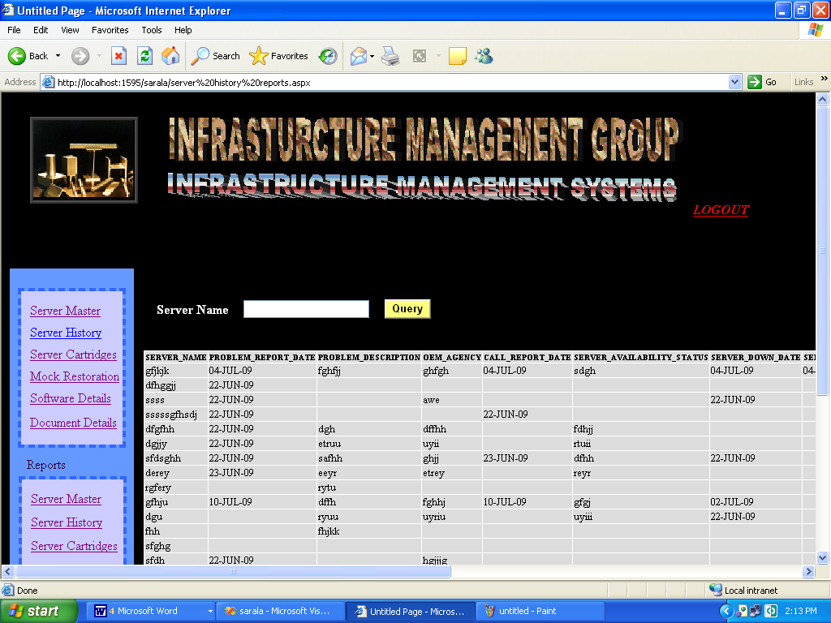

Cartridge Management

Description
Periodical backup is taken for various applications on request along with regular backup. Tape Cartridges are used for the backup. Cartridge details include cartridge name, backup number, state etc…
Input

Data Store:
- tssg_server_cartridges

Processing
After clicking Server Cartridges link in the home page Server Cartridges Screen will be displayed. There user can enter the details of server such as cartridge label, cartridge make, cartridge type etc.
Save
After entering the details of Cartridges in the corresponding text boxes, Save button is clicked to insert the record. If user has not entered the cartridge label or if cartridge label is not unique then a warning will be displayed as Cartridge label is Primary Key.
Query
All the details of Server Cartridges record will be populated in the corresponding text fields after clicking Query button by entering cartridge label in the corresponding text box. Cartridge label field is deactivated after query button is clicked. Because user should not modify the cartridge label

Update
Data is updated through the cartridge label. User enters the cartridge label and clicks Query button then corresponding record from the database is displayed in the text fields and if user wants to update the data, user can click Update button to update the record in the data base.

Clear
Clear button is clicked to erase the values in the text fields.

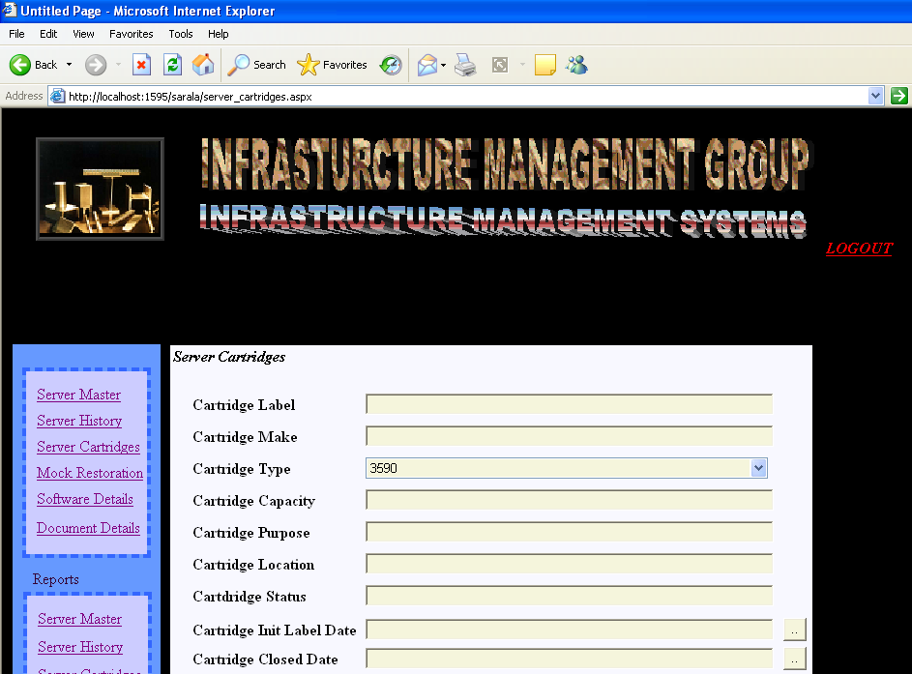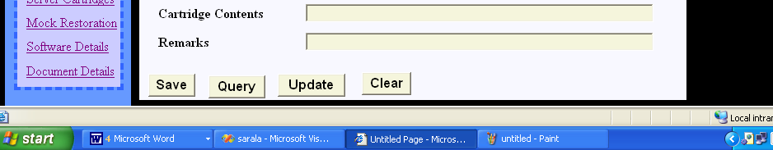

Server Cartridge Report:
To display all the details of server cartridges table user has to click the Server Cartridges reports link button, then server Cartridges reports screen will be displayed. There by clicking Query button all the record of server Cartridges table will be displayed. If user wants to see particular record of server history then he has to enter the cartridge label field before clicking Query button.

Report screen after clicking Query button is as shown below

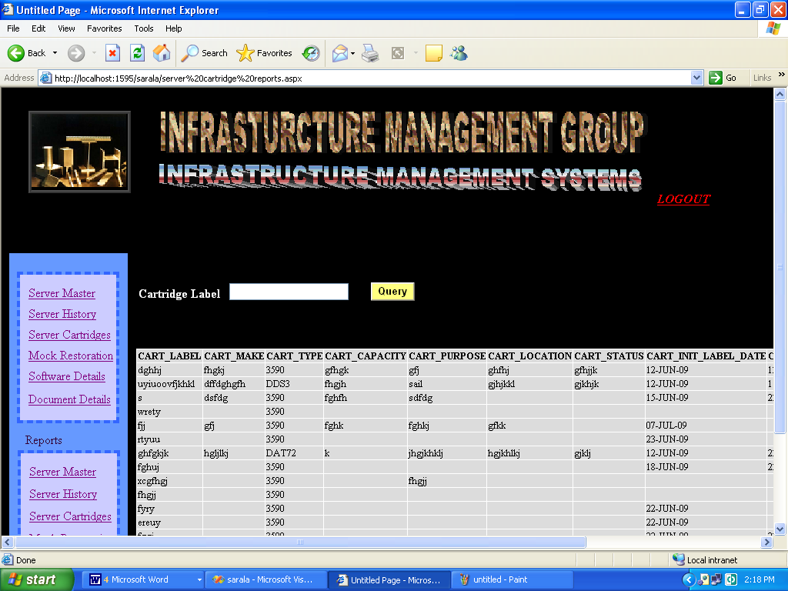

Mock Restoration

Description

Backed up data is restored whenever it is required. Mock Restorations are done to check the correctness of the data written on Cartridge. These details include cartridge name, restoration date etc….

Input

Data Store:
tssg_cartridges_mock_restore

Processing
After clicking Mock Restoration link in the home page Server Cartridges Screen will be displayed. There user can enter the details of server such as cartridge label, cartridge mock restore date, cartridge closed date etc.

Save
After entering the details of Mock Restoration in the corresponding text fields, Save button is clicked to insert the record. If user has not entered the cartridge label or if cartridge label is not unique then a warning will be displayed as Cartridge label is Primary Key.
Query
All the details of Mock Restoration record will be populated in the corresponding text fields after clicking Query button by entering cartridge label in the corresponding text box. Cartridge label field is deactivated after query button is clicked. Because user should not modify the cartridge label
Update
Data is updated through the cartridge label. User enters the cartridge label and clicks Query button then corresponding record from the database is displayed in the text fields and if user wants to update the data, user can click Update button to update the record in the data base.

Clear
Clear button is clicked to erase the values in the text fields.

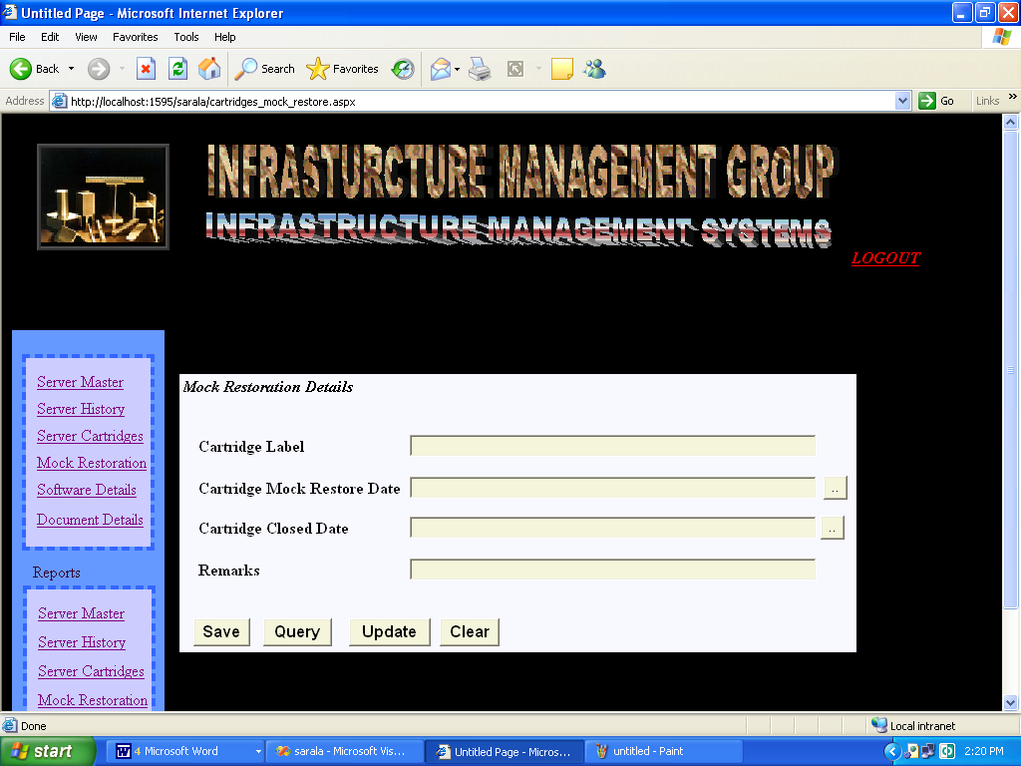

Mock Restoration Reports:
To display all the details of Mock Restoration table user has to click the Mock Restoration reports link button, then Mock Restoration reports screen will be displayed. There by clicking Query button all the record of mock Restoration table will be displayed. If user wants to see particular record of Mock Restoration then he has to enter the cartridge label field before clicking Query button.

Report screen after clicking Query button is as shown below

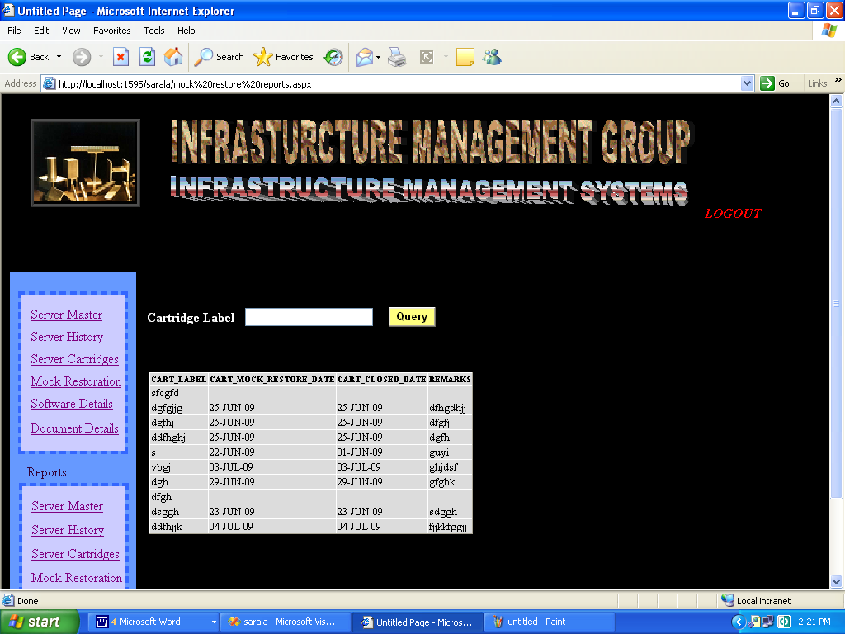

Software Management

Description
Software received along with various hardware devices are managed properly. Software type, hardware details and rack no are captured.

Input

Data Store:
tssg_software_details

Processing
After clicking Software Details link in the home page Software details Screen will be displayed. There user can enter the details of software such as media label, media location, software category etc.
Save
After entering the details of Software in the corresponding text fields, Save button is clicked to insert the record. If user has not entered the media label or if media label is not unique then a warning will be displayed as media label is Primary Key.
Query
All the details of software record will be populated in the corresponding text fields after clicking Query button by entering media label in the corresponding text box. Media label field is deactivated after query button is clicked. Because user should not modify the media label
Update
Data is updated through the media label. User enters the media label and clicks Query button then corresponding record from the database is displayed in the text fields and if user wants to update the data, user can click Update button to update the record in the data base.
Clear
Clear button is clicked to erase the values in the text fields.

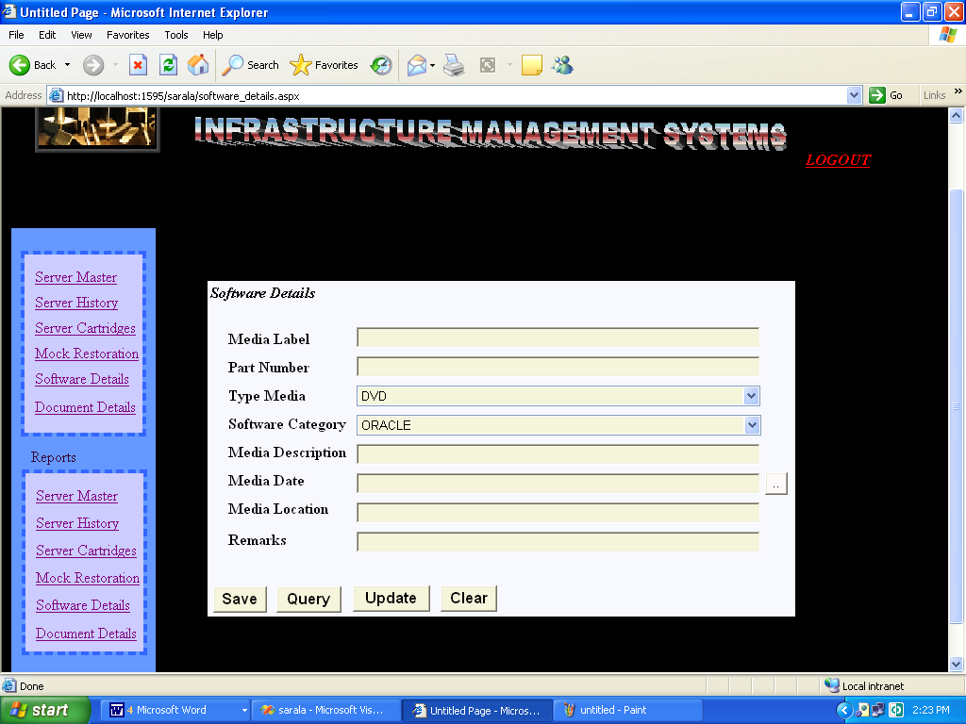

Software Details Reports:
To display all the details of software table user has to click the software details reports link button, then software details reports screen will be displayed. There by clicking Query button all the record of software details table will be displayed. If user wants to see particular record of software details then he has to enter the media label field before clicking Query button.
Report screen after clicking Query button is as shown below

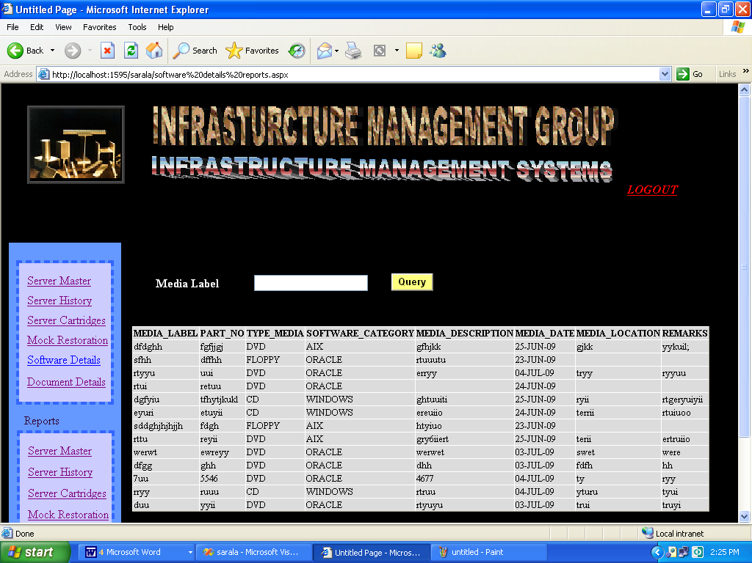

Document Management

Description
Various documents received along with servers are managed properly. Details of
the documents and their storage details are captured.
Input

Data Store:
tssg_document_details
Processing
After clicking Document Details link in the home page Document details Screen will be displayed. There user can enter the details of Document such as Document label, Document location, Document category etc.
Save
After entering the details of Document in the corresponding text fields, Save button is clicked to insert the record. If user has not entered the Document label or if Document label is not unique then a warning will be displayed as Document label is Primary Key.
Query
All the details of Document record will be populated in the corresponding text fields after clicking Query button by entering Document label in the corresponding text box. Document label field is deactivated after query button is clicked. Because user should not modify the Document label
Update
Data is updated through the document label. User enters the document label and clicks Query button then corresponding record from the database is displayed in the text fields and if user wants to update the data, user can click Update button to update the record in the data base.
Clear
Clear button is clicked to erase the values in the text fields.

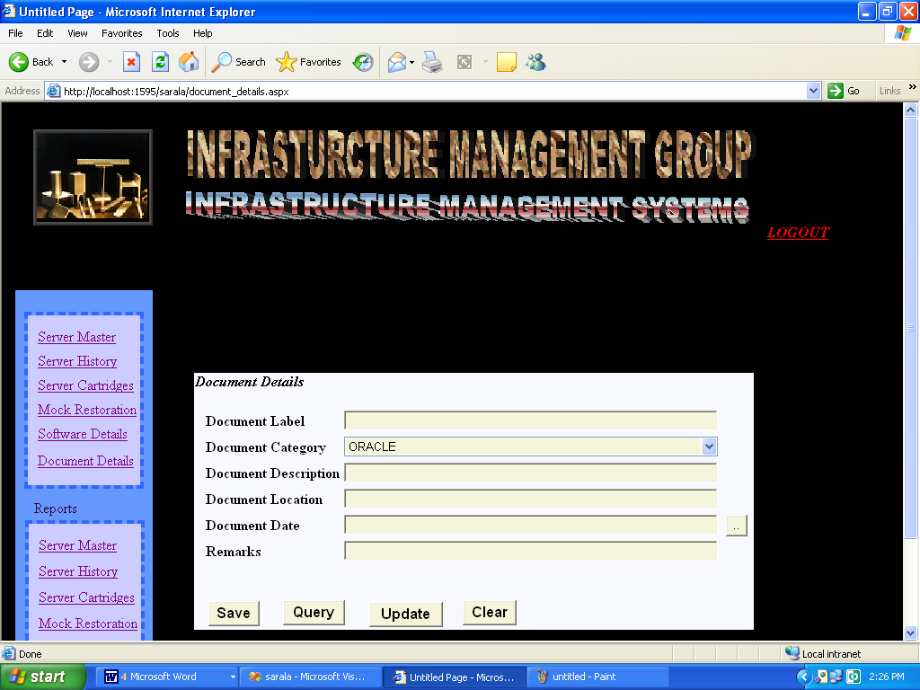

Document Details Reports:

To display all the details of document table user has to click the document details reports link button, then document details reports screen will be displayed. There by clicking Query button all the record of document details table will be displayed. If user wants to see particular record of document details then he has to enter the document label field before clicking Query button.

Report screen after clicking Query button is as shown below

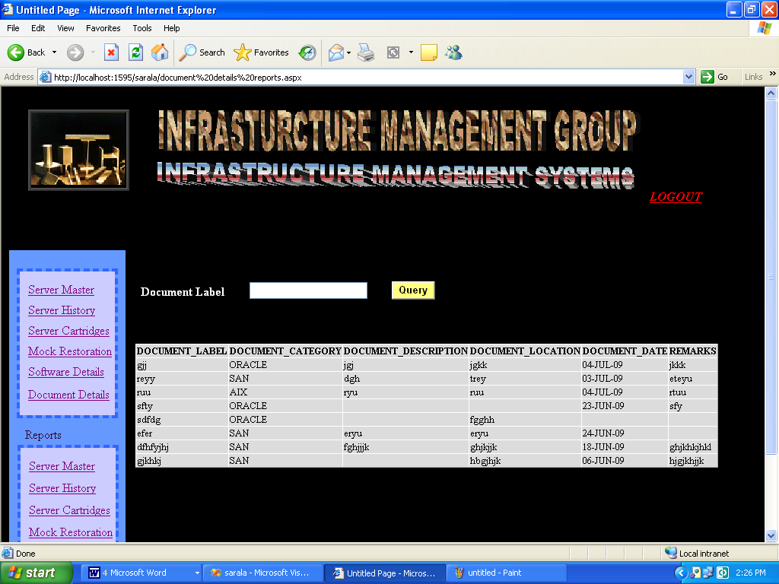

Non functional Requirements

The system will generally be available on 24 X 7 basis.
There will be no security features that will be explicitly built-into the system. The solution will leverage on the existing security mechanisms available in CUI.

Specific Requirements

NA

Assumptions/Dependencies/Limitations

NA

Acceptance Criteria

The IT Department shall accept the Servers management System on successful working of the all the features without any bugs reported in High, Medium or Low severity.

Acronyms and Glossary

Acronym | Abbreviation
IMS | Infrastructure Management Systems

Conclusion

The Project “Infrastructure Management System for Visakhapatnam steel plant” was successfully concluded by meeting the requirements specified by the software requirement document.
After careful verification and validation procedures, it has been confirmed that the system satisfies its user and system requirement.

Presently this application is for server Management and cartridge management. The current system can further be enhanced by extending this application to all infrastructure management in the department.

BIBLOGRAPHY

- Asp.Net Unleashed: Stephen Walther
- SQL The Complete Reference by sql press
- Software Engineering by Roger.S.Pressman
- Professional ASP.NET,C# by wrox
- Oracle 9i Ivan Bayross

